**Systems Guide**

**MongoDB Cloud**

Database Access page:

* To add new user, click on +ADD NEW DATABASE USER

+ADD NEW DATABASE USER:

* Choose Password as the Authentication Method -> Create a username and password for new user

* Select Built-in Role/Custom Roles/Specific Privileges for new user -> Click Add User

**MongoDB Compass**

Connect to Testing-Environment:

* Click on Connect

* Choose a connection method

* Connect using MongoDB Compass -> I have MongoDB Compass

* Choose your version of Compass -> Copy the connection string, then open MongoDB Compass

* Copy the connection string, then open MongoDB Compass -> New Connection (Authentication -> Username/Password [enter details] -> Connect)

Sample Dataset in MongoDB Atlas:

* Sample_Data -> Biking

**Overview:**

MongoDB cloud services are a collection of data products that help you build faster and more easily with data in any application. You can service any type of workload through a single API using Atlas Database (MongoDB's Database-as-a-Service), Search, and Data Lake.

For Redback Operations, Mango DB Cloud is the database management system. In future it will store and manage the company’s data.

Mango DB is very useful. Through the database access system of Mango DB, we can custom each user’s database. The IP addresses that are allowed to access the database can be seen in network access. MongoDB also contains sophisticated capabilities like continuous backups and point-in-time recovery to improve the stability of your mission-critical production databases.

**RESTful API**

API’s are integral part of communication between different components of the application. Therefore, considering the current requirement of the project we have created a Read API that will display the data from the Testing database.

In the future, as the data in the database increases and the requirement changes more API’s needs to be included for the smooth functioning of the Application. Such as the API to Update the data or the API to connect the database to the sensor for Data gathering purposes.

Following is the user Guide on how access the API already created with the Realm.

**To access the currently built Rest API**

**Log in to MongoDB Atlas**

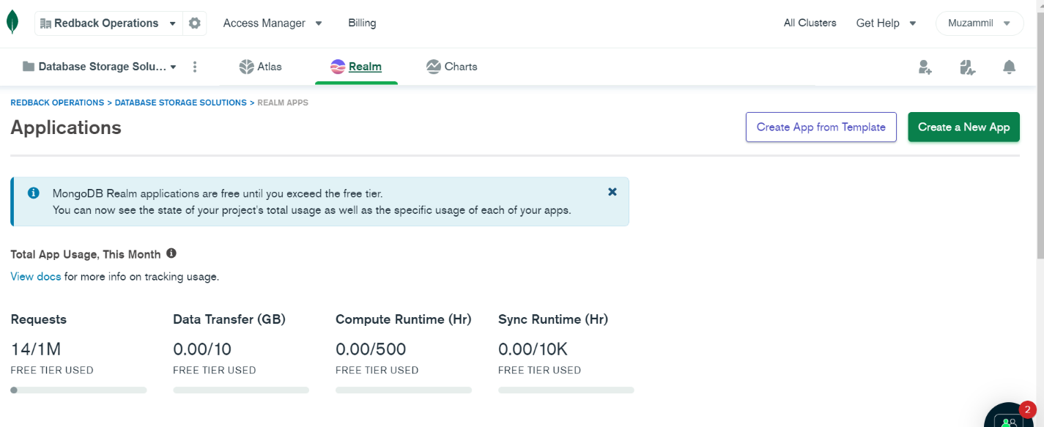

* Scroll down and you will find a Read API already created.

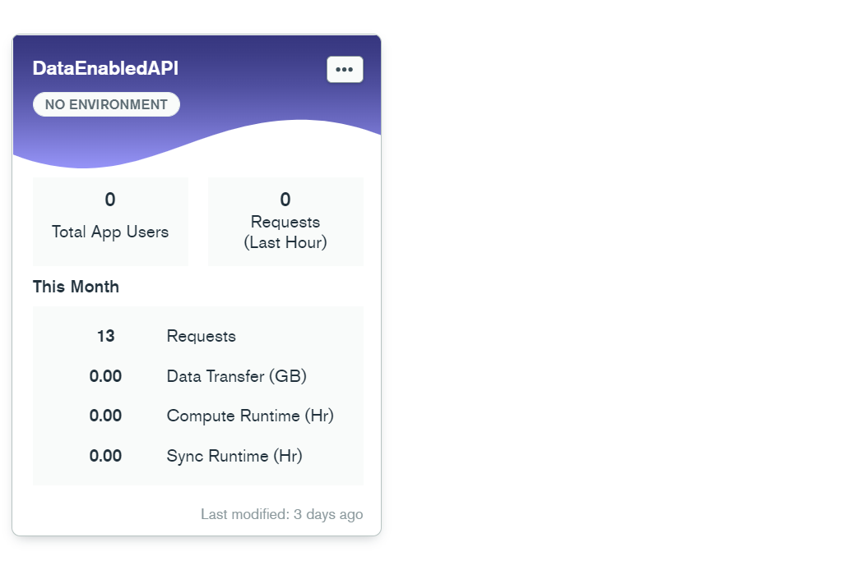

* Click on the App and open the Function Display Data.
* This will display the scripts used to create this API.

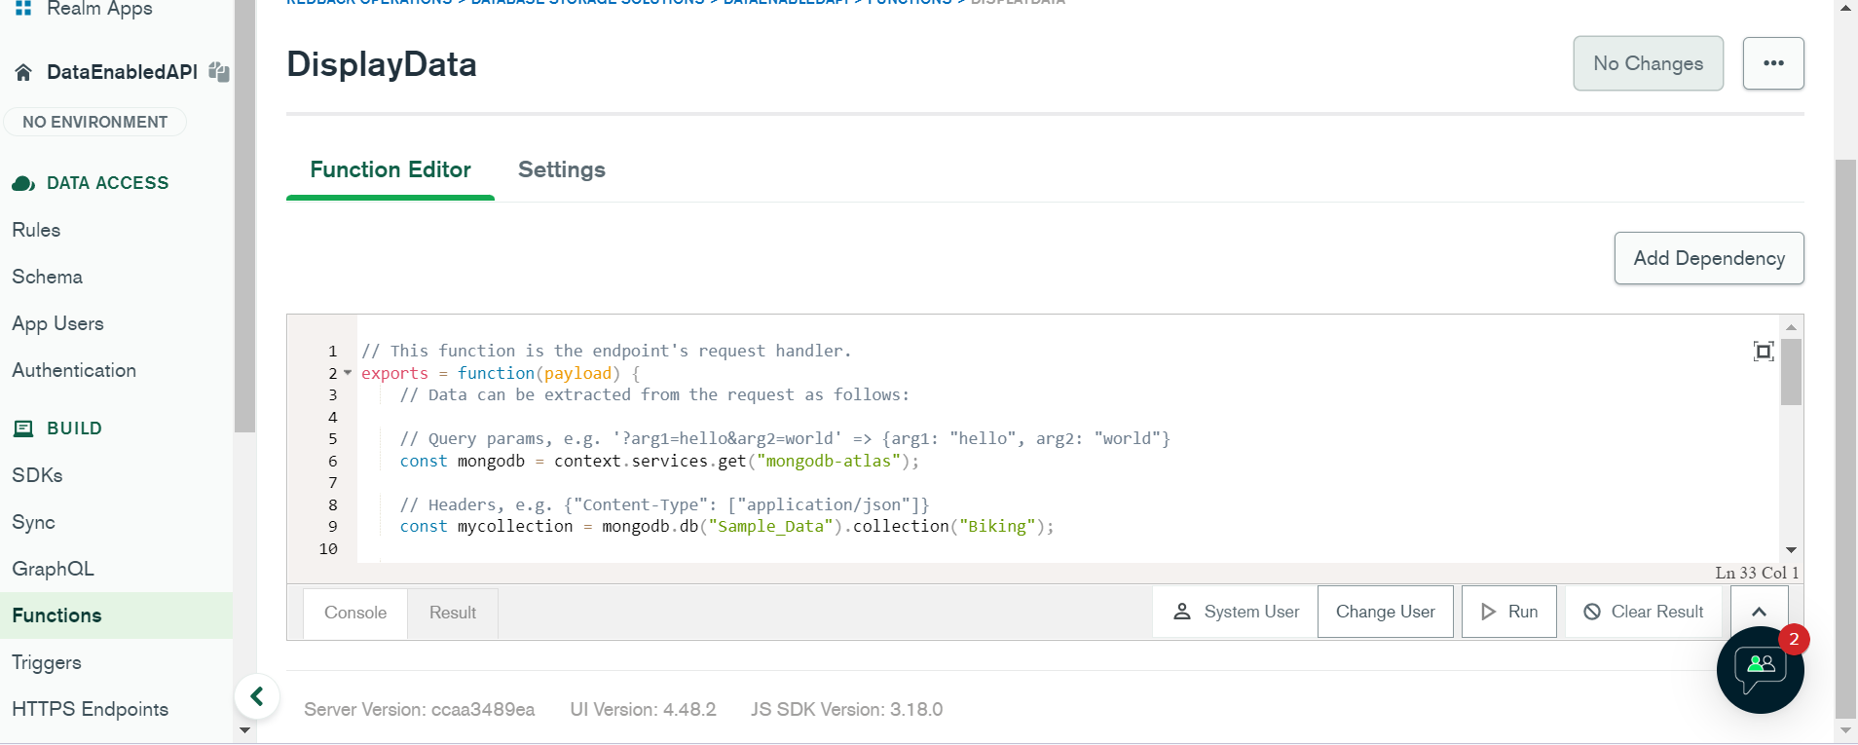

* By clicking on Run.

It will display the data in the form of an Array.

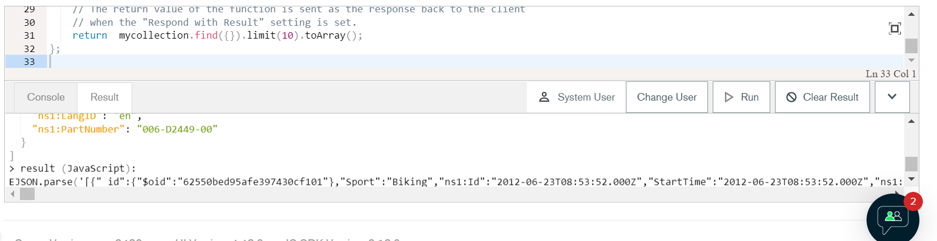

You can also use a third-party app called [Postman](https://www.postman.com/downloads/) for better display of the data.

**If Using Post man**

* You will need to create a connection.
* After creating an account in Postman
* Click on the + sign in the left panel to create a new collection.

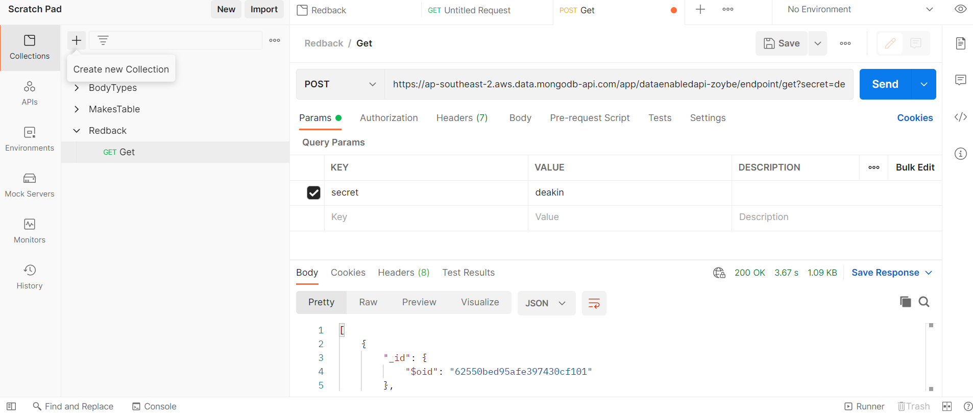

* Name the collection
* Now you have to create a connection between your already created API in MongoDB realm and the post man.
* In the API type set it to POST and in the string section copy and paste the string below.

<https://ap-southeast-2.aws.data.mongodb-api.com/app/dataenabledapi-zoybe/endpoint/get?secret=deakin>

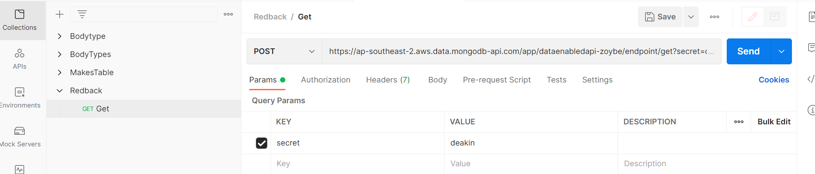



* Click on send button on the right.
* This should display the data value by value

